You’re Invited to the
District IX Spring Outing at
The Grove
1421 Milwaukee Ave., Glenview
Thursday, June 1, 2023
2-4:00 pm
For Members and Guests
$8 per person
See next page for details and registration

The Grove

An historical and ecological gem surrounded by suburban housing, businesses/retail and restaurants. Over 150 sprawling acres of oak-hickory savanna, wetland ponds, a nature museum, historic residence, original school, native Indian dwellings and more. Come and enjoy this unique view of nature, history and how Illinois was settled.

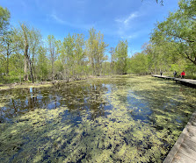
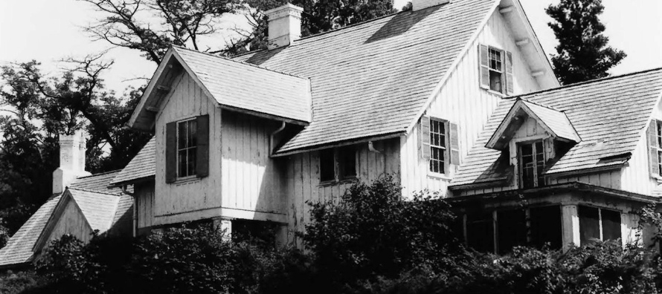

In 1836 visionary horticulturist and educator Dr. John Kennicott settled here from New Orleans, eventually building this family home.

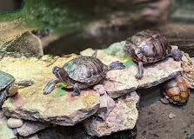

Learn how female conservationists stopped the bulldozers as Zenith Corp. was
starting to clear the land for a new headquarters. The story has a happy ending.
Registration form is on the next page.

Registration for District IX Spring Outing at
The Grove, 1421 Milwaukee Avenue, Glenview
Maintained by the Glenview Park District
June 1, 2023, 2-4 pm

Some details:

- District IX is offering this spring outing to members and guests.
- The per person cost is $8.
- Meet in the West Parking Lot.
- We will break up into smaller groups and docents will guide us through the walking tour.
- The grounds are handicapped accessible and people can self-select to be in the group that will provide a rest stop.
- Please register early so we have the proper number of docents; registration closes Friday, May 26.
- Rain or shine. This event will only be cancelled if there are heavy storms; be sure to write your email address clearly so you can be contacted.
- Following the tours, you are welcome to explore more on your own.
- There will be no planned luncheon arrangements, but numerous restaurants are in the immediate area.
- Questions: call or email Diane Freeman, 847-564-1777, cell 847-204-8426; ddf@ameritech.net

_____________________________________________________________________________________________

Registration:

Name ________________________________________________________________________________________

Phone _______________________ Address__________________________________________________________

Email __________________________________________________________________
(your email will suffice for both you and your guest, if you bring one)

Your Phone _____________________

Your Club ___________________________________________________________________

Name of Guest ________________________________________________________________

Cost/$8 per person – Total _________________
Make Checks payable to District IX/GCI and mail to Diane Freeman, 3001 Cherry Ln., Northbrook 60062

